Name of the Student | Uppu Sye Kumar
Reg. No | 192325121
GitHub Link | https://github.com/syekumar/MLA0405-Deep-Learning

SIMATS ENGINEERING
CO3 - ASSESSMENT TOOL 1
Case Study
COURSE NAME: DEEP LEARNING COURSE CODE: MLA04
SLOT : D
COURSE OUTCOME COVERED
CO3: Analyze and apply convolutional neural network architectures, including convolutional layers, filters, parameter sharing, regularization, AlexNet and ResNet, to develop solutions for image classification and real-world computer vision applications. (L4)
CO Weightage: 25% | Duration: 90 minutes
Assessment Tool Weightage: 25% | Marks: 25
Code of Conduct:
I Uppu Sye Kumar/192325121 (Name / Reg No) certify that this submission is my original work and that I have adhered to the guidelines specified for this assessment.
I understand that any violation of academic integrity rules will result in disciplinary action.
Signature of the student:U.SyeKuma Name of the student:Uppu Sye Kumar
Criteria | Conceptual  Understandin g  (2.5) |  | Linkages (2.5) | Organizatio n  (2) | Integration of  Literature  (2) |  | Clarity &  Presentatio n  (1) | Total  (10)
Weightage | 25 % |  | 25% | 20% | 20 % |  | 10 % | 100  %
Q1
Q2
Total
Signature of the Faculty: |  |  |  |  |  | Total Marks :
QUESTIONS:02 |  |  |  |  |  | Total Marks: 20
Case Study Question 1: CNN for Automated Medical Image Classification (10 Marks)
A healthcare organization wants to develop a deep learning system to automatically classify chest X-ray images into normal and disease-affected categories. The dataset contains thousands of X-ray images with variations in size, brightness and image quality. A CNN model is proposed because it can automatically learn important visual features such as edges, textures, and abnormal regions without manually designing features.
Question:
- Design and explain a suitable CNN architecture for this medical image classification system.
- Describe the motivation for using CNNs and explain the role of convolutional layers, filters, pooling layers, and fully connected layers in the proposed architecture.
- Explain how parameter sharing reduces the number of trainable parameters compared with a fully connected network.
- Discuss suitable regularization techniques such as dropout, data augmentation and batch normalization to reduce overfitting.
- Finally, explain whether AlexNet or ResNet would be more appropriate for this application and justify your choice based on feature learning, network depth, computational requirements and classification performance.
1. Suitable CNN Architecture
A suitable architecture for chest X-ray classification is:
Input Image → Convolution → ReLU → Batch Normalization → Max Pooling → Convolution → ReLU → Max Pooling → Convolution → ReLU → Max Pooling → Flatten → Fully Connected → Dropout → Output
Proposed architecture
Layer | Configuration | Purpose
Input | 224 × 224 × 1 | Standardized chest X-ray
Conv1 | 32 filters, 3×3 | Detect edges and simple patterns
ReLU | — | Introduce non-linearity
Batch Normalization | — | Stabilize and speed up training
Max Pooling | 2×2 | Reduce spatial dimensions
Conv2 | 64 filters, 3×3 | Learn textures and shapes
ReLU + Pooling | — | Non-linearity and dimensionality reduction
Conv3 | 128 filters, 3×3 | Learn complex abnormalities
ReLU + Pooling | — | Extract higher-level features
Flatten | — | Convert feature maps into vector
Dense | 128 neurons | Perform classification
Dropout | 0.5 | Reduce overfitting
Output | 2 neurons + Softmax | Normal / Disease
Image needed here: CNN Architecture Diagram
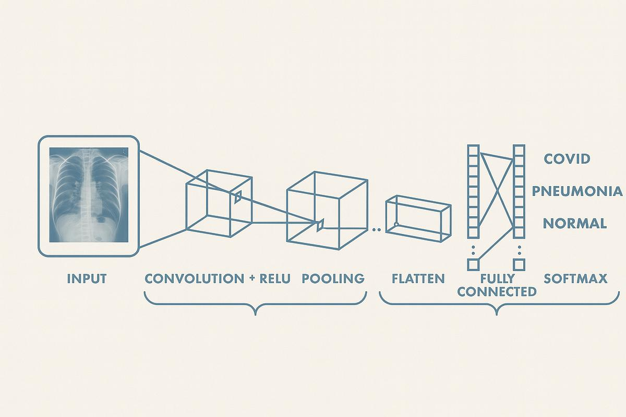
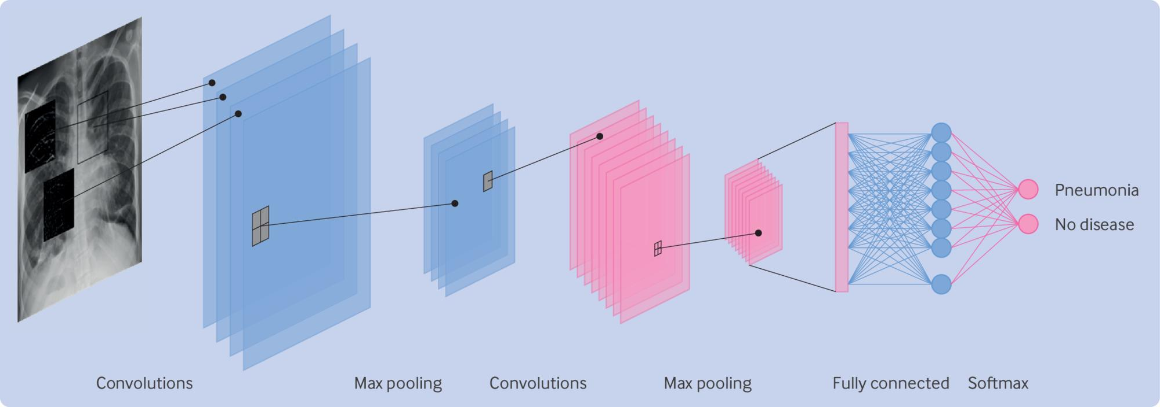
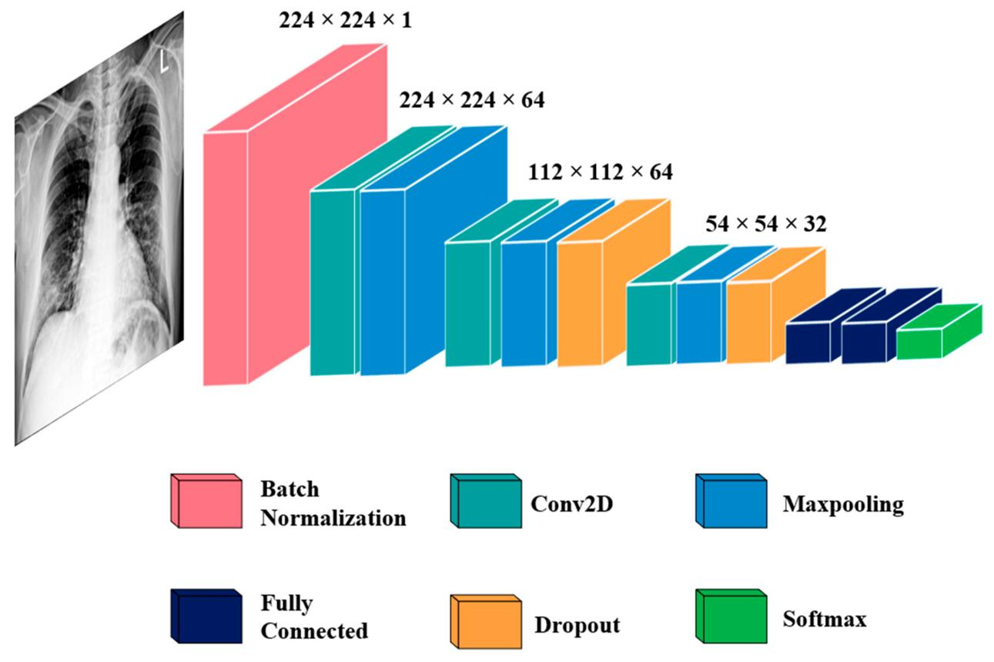
5
The X-ray images should first be resized to a common size and normalized. Data augmentation can then generate variations of the training images.

2. Motivation and Role of CNN Components
Why CNN?
CNNs are highly suitable for medical images because they automatically learn spatial features without manually designing features.
For an X-ray:
Low-level features → Edges → Textures → Shapes → Anatomical patterns → Disease-related regions
Convolutional Layer
A convolutional layer applies small filters over the image.
For example, a 3 × 3 filter moves across the image and detects patterns such as edges, lines and textures.
Early layers learn simple features, while deeper layers learn complex features such as abnormal structures.
Filters
Filters are trainable matrices whose values are learned during training.
Different filters can detect:
- Horizontal edges
- Vertical edges
- Textures
- Boundaries
- Shapes
- Abnormal regions
Pooling Layer
Pooling reduces the spatial size of feature maps.
Max Pooling selects the maximum value from a small region.
Advantages:
- Reduces computation
- Reduces memory requirements
- Helps prevent overfitting
- Makes features less sensitive to small image translations
Fully Connected Layer
After convolution and pooling, the feature maps are flattened into a vector.
The fully connected layer combines these learned features to determine whether the X-ray is Normal or Disease-Affected.

3. Parameter Sharing
Parameter sharing is one of the most important advantages of CNNs.
Suppose an image is 224 × 224 pixels.
A fully connected neuron connected to every pixel would require:
weights for just one neuron.
In a CNN, a 3 × 3 filter contains only:
weights, plus a bias.
The same 3 × 3 filter is reused across different locations of the image.
Therefore:
CNN → Same filter reused across the image → Far fewer parameters
This reduces:
- Memory requirements
- Computational cost
- Training time
- Risk of overfitting
It also allows the CNN to detect the same feature regardless of where it appears in the image.

4. Regularization Techniques
Medical datasets may contain thousands of images, but the model can still overfit.
a) Data Augmentation
Training images can be randomly modified using:
- Small rotations
- Horizontal shifts
- Scaling
- Cropping
- Brightness changes
- Contrast changes
This increases the effective diversity of the dataset.
Important: Augmentation must preserve clinically meaningful information. Excessive transformations should be avoided.
b) Dropout
Dropout randomly disables some neurons during training.
For example:
Dropout = 0.5
means approximately 50% of selected neurons are randomly ignored during each training step.
This prevents neurons from becoming overly dependent on each other.
c) Batch Normalization
Batch normalization normalizes intermediate activations during training.
Benefits:
- More stable training
- Faster convergence
- Allows suitable learning rates
- Can provide some regularization
Other useful techniques include early stopping, L2 regularization and transfer learning.

5. AlexNet vs ResNet
Feature | AlexNet | ResNet
Architecture | Relatively simple | Uses residual/skip connections
Depth | 8 learned layers | Can have 18, 34, 50, 101+ layers
Feature learning | Good | Excellent
Training deep networks | More difficult | Easier
Vanishing gradients | More susceptible | Reduced by skip connections
Parameters | Relatively high for its age | Efficient for its depth
Medical image performance | Good baseline | Usually better
Computational requirement | Lower for original model | Depends on ResNet version
Modern suitability | Moderate | High
Recommendation: ResNet
ResNet is more appropriate for this application.
The main reason is its residual/skip connections, which allow information and gradients to flow more easily through a deep network.
For example:
Input → Several convolutional layers → Skip connection → Output
This makes it possible to learn deeper and more discriminative features.
A suitable practical choice would be ResNet-18 or ResNet-34 when computational resources are limited.
For a medical application, transfer learning from a pretrained ResNet can also reduce training requirements and improve performance.
Final conclusion
ResNet > AlexNet for this case because it provides:
- Better feature representation
- Deeper learning capability
- Better gradient flow
- Strong classification performance
- Good transfer-learning capability
However, the final medical system must be clinically validated; accuracy alone should not determine deployment.

Case Study Question 2: CNN-Based Autonomous Vehicle Object Recognition (10 Marks)
An autonomous vehicle company is developing a vision system that must identify cars, pedestrians, traffic signs, bicycles, and road obstacles from images captured by cameras mounted on the vehicle. The system must recognize objects under different lighting conditions, viewing angles, distances and road environments. The development team is considering AlexNet and ResNet architectures for building the CNN-based recognition system.
Question:
- Analyze how a CNN architecture can be designed for this autonomous vehicle application.
- Explain the purpose of the input, convolution, activation, pooling, and fully connected/output layers and describe how convolutional filters progressively learn low-level and high-level features.
- Explain the importance of parameter sharing in reducing computational complexity and improving translation-related feature detection.
- Discuss the possible problem of overfitting and recommend suitable regularization methods.
- Compare AlexNet and ResNet in terms of architecture, depth, parameter efficiency, training difficulty, vanishing-gradient problems and feature-learning capability.
- Finally, recommend the most suitable architecture for the autonomous vehicle system and justify your decision based on accuracy, computational cost and real-time application requirements.

1. CNN Architecture Design
The autonomous vehicle needs to identify multiple classes such as:
- Cars
- Pedestrians
- Bicycles
- Traffic signs
- Road obstacles
A suitable CNN pipeline is:
Camera Image → Preprocessing → Convolution → ReLU → Pooling → Convolution → ReLU → Pooling → Deep Convolutional Layers → Fully Connected/Detection Head → Output
For simple image classification, the output can use Softmax.
For a real autonomous vehicle, however, object detection is generally more appropriate because the system must determine both what the object is and where it is.
Image needed here: CNN object-recognition pipeline
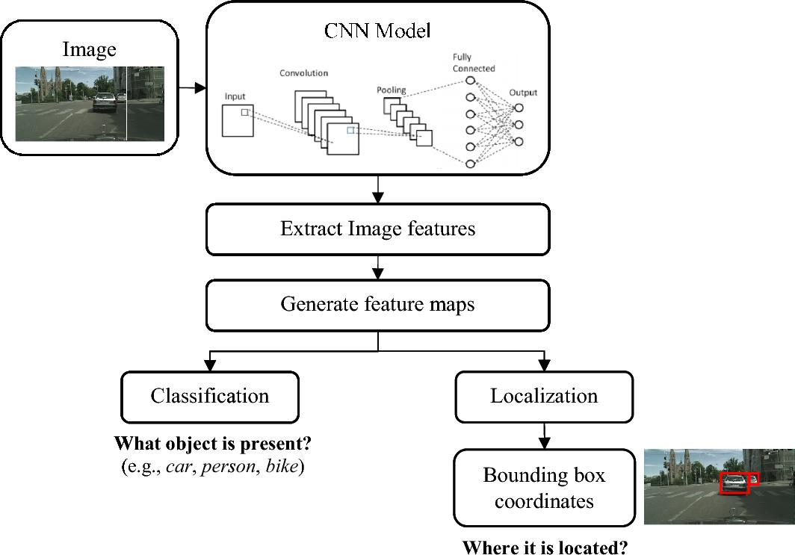
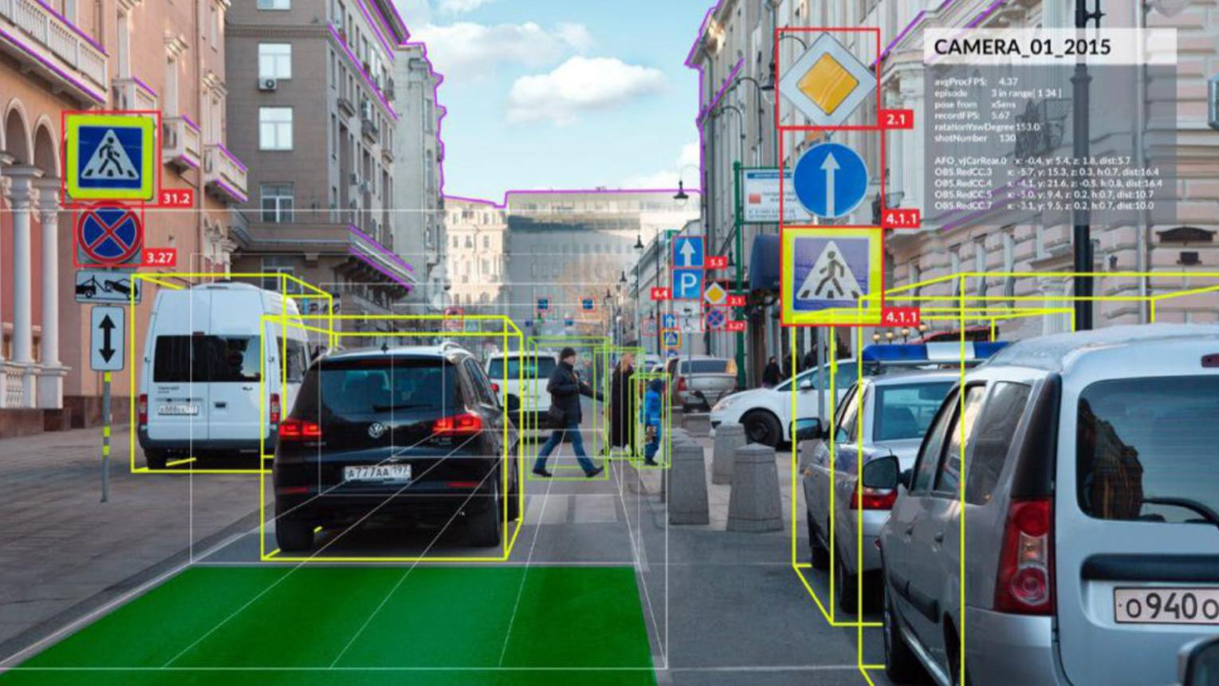
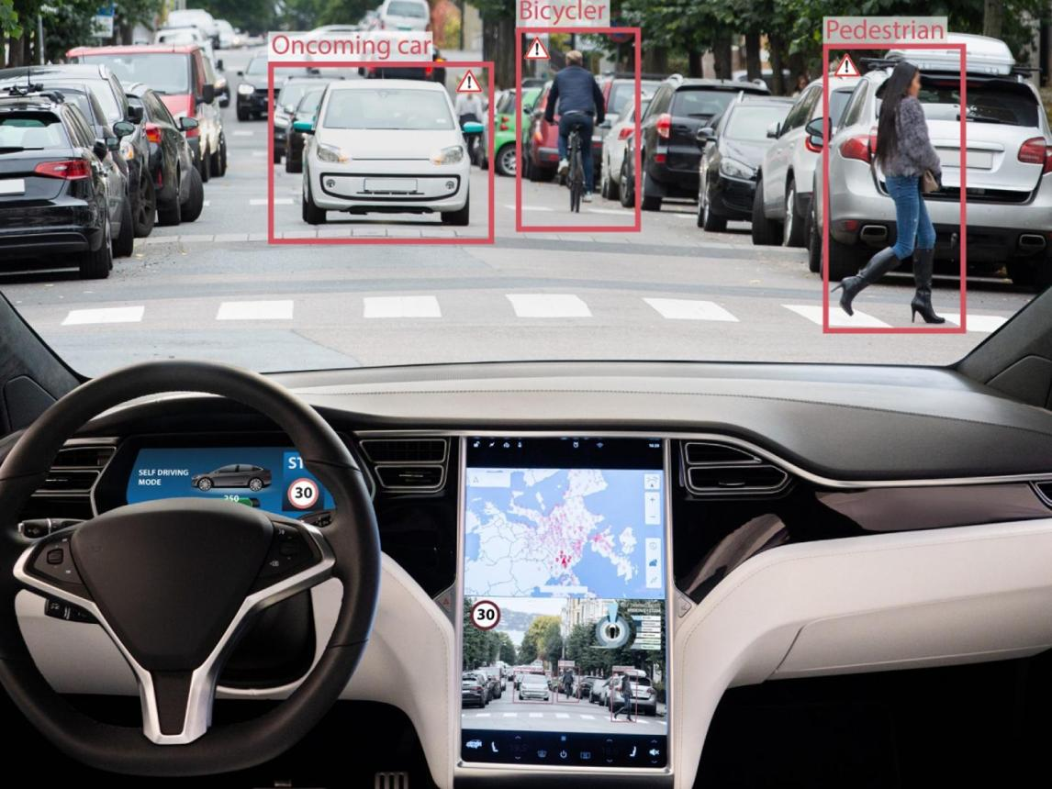
4

2. Purpose of CNN Layers
Input Layer
Receives images from vehicle-mounted cameras.
Example:
224 × 224 × 3
where 3 represents RGB channels.
Images should be resized and normalized before entering the network.
Convolution Layer
Convolutional filters scan the image and extract visual patterns.
The learning process is approximately:
Layer 1:
Edges, lines and colors
↓
Layer 2:
Textures and simple shapes
↓
Layer 3:
Parts of objects
↓
Deeper layers:
Cars, pedestrians, signs and road obstacles
Thus, deeper layers provide increasingly meaningful representations.
Activation Layer
Usually ReLU is used:
It introduces non-linearity, allowing the network to learn complex relationships.
Pooling Layer
Pooling reduces feature-map dimensions.
For example, 2 × 2 max pooling reduces the spatial resolution while retaining important features.
Fully Connected / Output Layer
The final learned representation is used to classify the object.
For example:
Car | Pedestrian | Bicycle | Sign | Obstacle
For autonomous driving, a detection head is generally preferable to a simple fully connected classifier because it can predict bounding boxes + class labels.

3. Importance of Parameter Sharing
In CNNs, the same filter is applied at different locations.
For example, a filter that learns the shape of a wheel can detect a wheel whether it occurs on the left or right side of the image.
This is called parameter sharing.
Advantages
- Fewer parameters
- Lower memory consumption
- Reduced computation
- Faster training
- Better translation-related feature detection
Instead of learning separate weights for every pixel location, CNNs reuse the same filter throughout the image.
Therefore:
Parameter sharing → fewer parameters → lower computational cost → efficient visual recognition
This is particularly important in autonomous vehicles because the system needs to operate in real time.

4. Overfitting and Regularization
Autonomous vehicle datasets can contain large variations in:
- Weather
- Lighting
- Camera angle
- Object distance
- Road conditions
- Traffic density
- Backgrounds
If the CNN memorizes training images instead of learning general features, overfitting occurs.
Suitable techniques
1. Data Augmentation
Generate variations using:
- Rotation
- Scaling
- Cropping
- Translation
- Brightness variation
- Contrast variation
- Noise
2. Dropout
Randomly disables neurons during training and reduces dependence between neurons.
3. Batch Normalization
Improves training stability and can provide regularization.
4. L2 Regularization
Penalizes excessively large weights.
5. Early Stopping
Training is stopped when validation performance stops improving.
6. Transfer Learning
A model pretrained on a large image dataset can be fine-tuned using vehicle-specific data.

5AlexNet vs ResNet

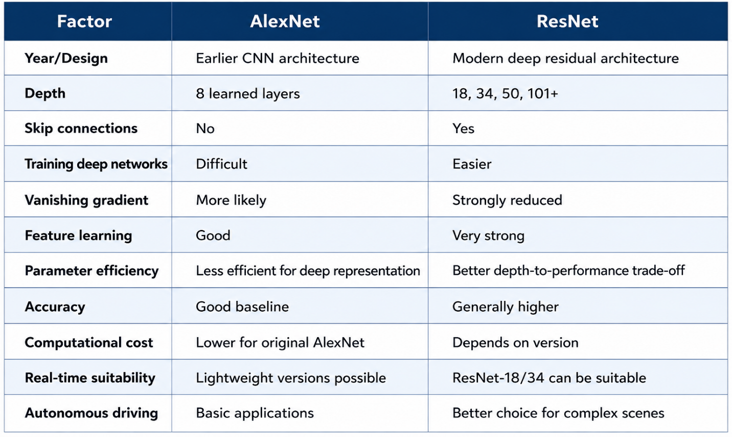

Vanishing Gradient Problem
In very deep networks, gradients can become extremely small while moving backward through the network.
This makes earlier layers difficult to train.
ResNet addresses this using skip connections:
Instead of forcing the layers to learn the complete transformation, they learn a residual function .
This improves gradient flow and makes deeper networks easier to train.

6. Final Recommendation
Recommended architecture: ResNet
For autonomous vehicle object recognition, ResNet is the better choice, particularly a computationally efficient version such as ResNet-18 or ResNet-34 when real-time processing is important.
Justification
Accuracy:
ResNet can learn more complex visual features and generally provides stronger recognition performance.
Feature learning:
Its deeper architecture can learn hierarchical features from simple edges to complex objects.
Training:
Skip connections reduce the vanishing-gradient problem.
Computational cost:
Although deep ResNet models can be computationally expensive, smaller variants such as ResNet-18 provide a useful balance between accuracy and speed.
Real-time requirement:
For an actual autonomous vehicle, the CNN backbone should be combined with an efficient object-detection framework and optimized using techniques such as model compression, quantization or hardware acceleration when necessary.
Overall decision
because it provides a better accuracy–feature-learning–computational-cost trade-off.

RUBRICS FOR CALCULATION:
Criteria | Weightage | Level 4 –  Exemplary | Level 3 – Proficient | Level 2 –  Developing | Level 1 – Beginning
Understanding of Case | 25 | Thorough understanding; clearly  identifies all  key issues | Good understanding with most issues identified | Basic understanding  ; some issues missed | Poor understanding;  problem not  identified correctly
Application of Concepts | 25 | Effectively applies relevant concepts to  analyze the case deeply | Applies appropriate  concepts with  minor gaps | Limited application of concepts | Fails to apply relevant concepts
Analysis | 20 | In-depth analysis with strong  reasoning and insights | Good analysis with logical reasoning | Basic analysis with limited depth | Weak or no analysis; lacks reasoning
Solution Design | 20 | Innovative, feasible  solutions with strong justification | Logical solutions with adequate justification | Basic solutions with weak  justification | Incorrect or no solution provided
Clarity | 10 | Clear, wellstructured, and easy to understand | Organized and understandable  presentation | Limited clarity and structure | Poor clarity; difficult to understand

